***BASAVESHWAR ENGINEERING COLLEGE (autonomous) Bagalkot***



***Department of Electronics and Communication Engineering***

|  |
| --- |
| Subject: Control the speed of the DC motor  Name: Gayatri Vital Madhavi Name: Deepa R Sanakyannvar  USN: 2BA20EC027 USN: 2BA20EC024  Roll No: 24 Roll No: 21  Faculty Name: M C Aralimard |

* Introduction:

First to begin with, an electric motor is a machine that uses electricity to turn a shaft, thereby converting electrical energy into mechanical energy. Electric motors are broadly divided into the following three types.

* DC motors
* AC motors
* Stepper motors

DC motors are further divided into brushed DC motors and brushless DC motors. Brushed DC motors have coils in their rotor, and alters the way current flows through the coils based on a mechanism using commutators and brushes. Brushed DC motors generate electrical and acoustic noise, and require frequent maintenance because their brushes and commutator are both consumable parts. But, they also feature a simple design and can operate without an electronic drive circuit if speed control is not needed.

A brushless DC motor, in contrast, avoids the need for a commutator and brushes by having a permanent magnet in the rotor. This, however, means they require a drive circuit. They also feature low maintenance, quiet operation, and long life.

* **Motor speed control**

Use of these techniques allows the flexible adjustment of DC motor speed. However, additional control is required to keep a motor running at a constant speed. This is because the motor’s load torque varies due to the load itself, as well as other factors such as temperature, humidity, and changes over time. Simply driving the motor with a constant voltage will result in its speed fluctuating with changes in load.

Maintaining a constant speed despite a variable load requires that the drive voltage be continually adjusted in response to these changes in load. The graph below shows an example where the load torque for a motor operating at a speed of ω0 reduces from T1 to T0, in which case reducing the drive voltage to V0 keeps the motor speed at ω0. If the torque instead increases to T2, maintaining a constant motor speed of ω0 requires that the drive voltage increase to V2.

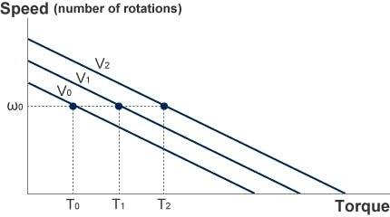Speed control

The speed is measured by a sensor attached to the motor. The difference between the measured and desired motor speed (speed error) is calculated, and the drive voltage is controlled in such a way that it is increased if the speed is too slow and reduced if the speed is too high. Doing this maintains a constant motor speed. While past practice was to use op amps or other analog circuits to control the drive voltage, the use of microcomputers has become the norm in recent years.

**Circuit diagram of DC motor speed control**

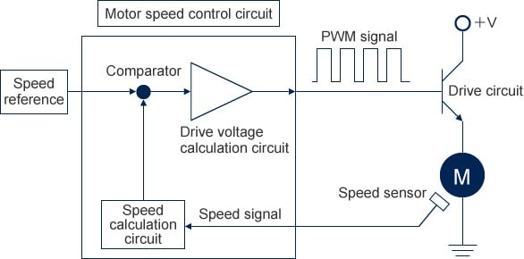Speed control circuit for brushless DC motor

1. Speed sensor

Outputs a signal indicating the motor speed. Devices used for this purpose include Hall-effect sensors, encoders, and tachogenerators.

1. Speed detection circuit

Calculates the motor speed from the speed sensor signal.

1. Speed reference

Outputs the target motor speed.

1. Comparator

Calculates the difference between the speed reference and measured speed.

1. Drive voltage calculation circuit

Calculates the motor drive voltage based on the calculated speed error.

1. Drive circuit

A circuit that adjusts the voltage applied to the motor in accordance with the drive voltage signal.

A DC motor can achieve steady operation by controlling its speed to remain constant regardless of changes in load. These motors are also suitable for a wide variety of control practices that can be implemented using a microcomputer. DC motors find uses in many different applications that take advantage of their ease of control.

* **Applications**
* Air compressor
* Carnes
* Lifts
* Vaccum cleaner and in speed regulations application
* Electric traction
* Elevators
* **Adavantages**
* Simpler installation and maintance
* High startup power and torque
* Fast response times to starting ,stoping and acceleration
* Availability in several standard voltages
* Verilog statements

always statement:

Synatx : always @(sensitivity-list);

//sensitivity-list can be @ (A or B)

begin

sequentianal statements

end

If statement:

Synatx : if (condition)

sequential statements 1

else

sequential statements 2

end

* Verilog code:

module dc_motor(psw,pdcm,clk);

input[2:0]psw;//3 bit programble switch to control speed of the dc motor

output pdcm;

input clk;

reg pdcm;

reg [7:0]cnt;//for every clock pulses divide the clock

reg [7:0]sclkdiv;//to vary the speed of dc motor

wire clk1;

always @(posedge clk)

begin:p1

cnt<=cnt+1;

end

assign clk1=cnt[7];

always @ (posedge clk1)

begin:p2

if(sclkdiv===12'b101011110000)// hexa=af0 , deci=2800

begin

sclkdiv<=12'b000000000000;

end

else

begin

sclkdiv<=sclkdiv+1;

end

end

always @(posedge clk1)

begin:p3

if(sclkdiv===12'b000000000000)

begin

pdcm<=1'b1;

end

else if(psw==3'b000&sclkdiv==12'b000111110100)//hexa=1f4, deci=500

begin

pdcm<=1'b0;

end

else if(psw==3'b001&sclkdiv==12'b001100100000)//hexa=320,deci=800

begin

pdcm<=1'b0;

end

else if(psw==3'b010&sclkdiv==12'b010001001100)//hexa=44c,deci=1100

begin

pdcm<=1'b0;

end

else if(psw==3'b011&sclkdiv==12'b010101111000)//hexa=578,deci=1400

begin

pdcm<=1'b0;

end

else if(psw==3'b100&sclkdiv==12'b011010100100)//hexa=6a4,deci=1700

begin

pdcm<=1'b0;

end

else if(psw==3'b101&sclkdiv==12'b011111010000)//hexa=7d0,deci=2000

begin

pdcm<=1'b0;

end

else if(psw==3'b110&sclkdiv==12'b100011111100)//hexa=9fc,deci=2300

begin

pdcm<=1'b0;

end

else if(psw==3'b111&sclkdiv==12'b100111000100)//hexa=9c4,deci=2600

begin

pdcm<=1'b0;

end

end

endmodule

* **RTL viewer**

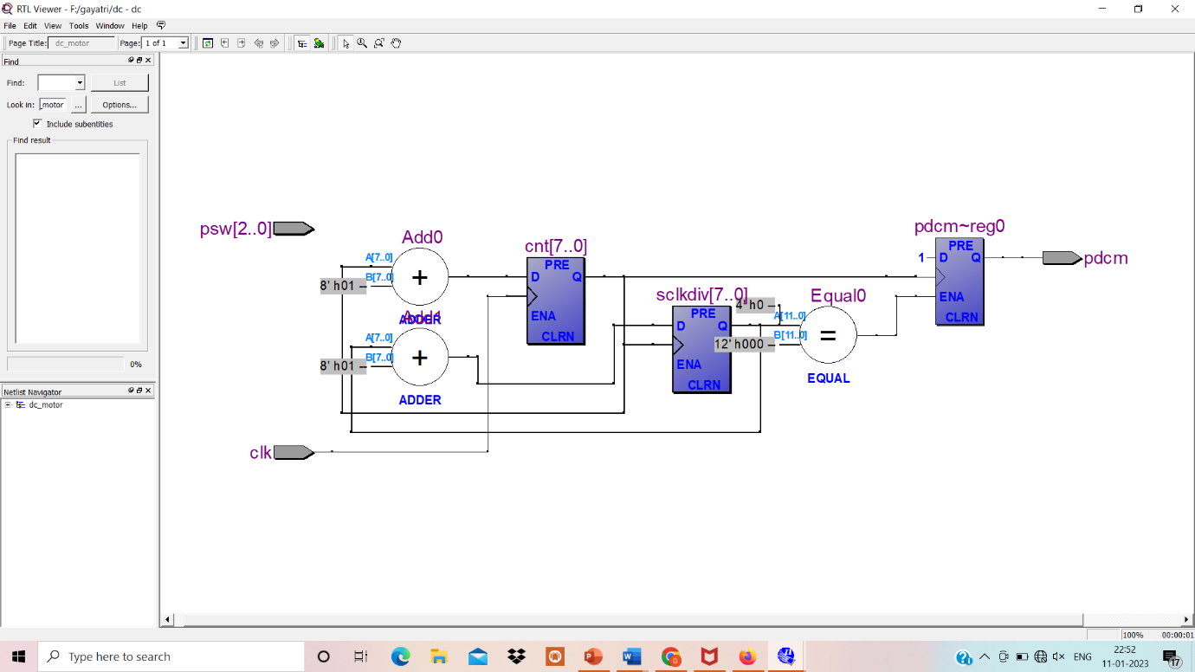

* **Result**

